Enter some numbers! Remember that you can change the column name by clicking on it. You want to make sure each person get their own row (i.e. go down not across).

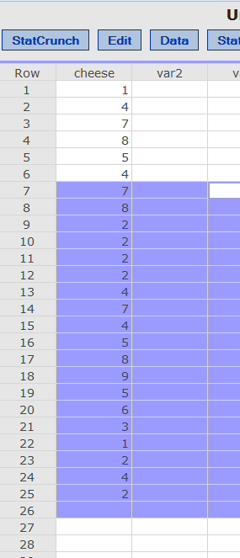

Click “Stat” and select “Tables > Frequency”.

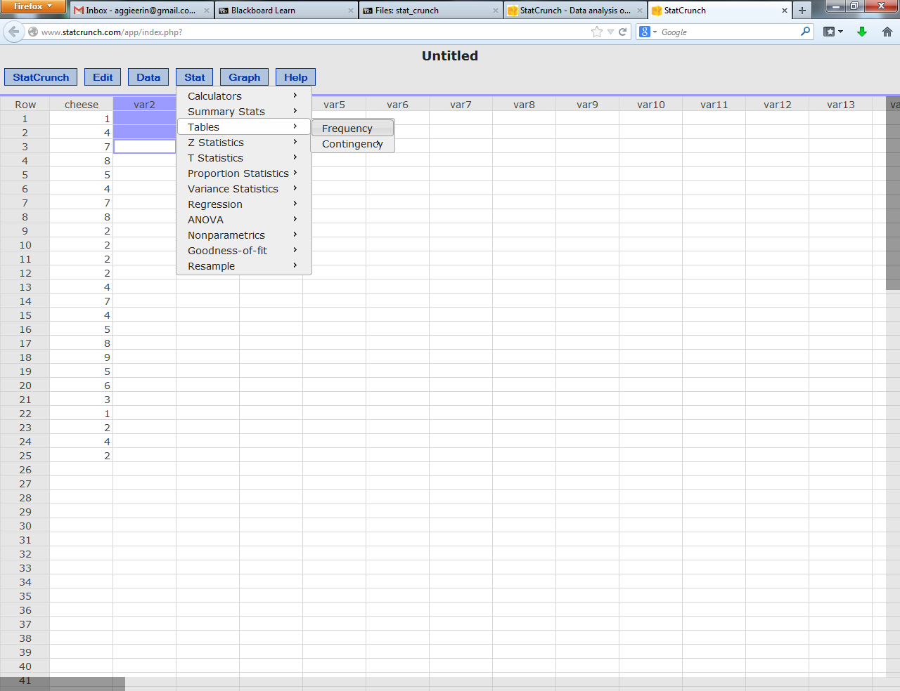

Click on the variable you want to create the frequency table for (i.e. cheese here).

Be sure to select both frequency and percent of total for your options.

Hit compute.

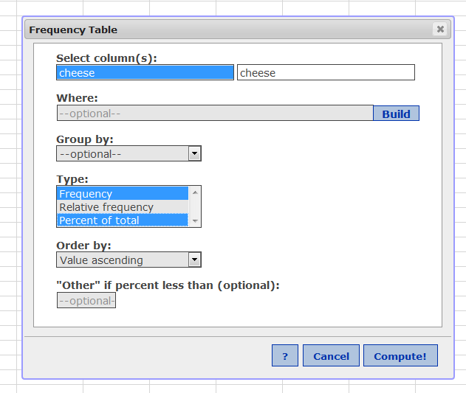

You can copy the graph to cut and paste into excel or word by hitting options (copy).

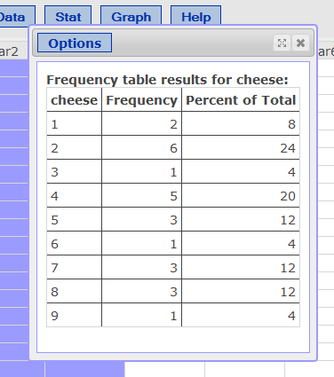

Cheese = the possible values.

Frequency = frequency of those values.

Relative frequency = proportion. (if you select it)

Percent = the percentage of the total for each frequency.

Click “Graphics” and select “Histogram”

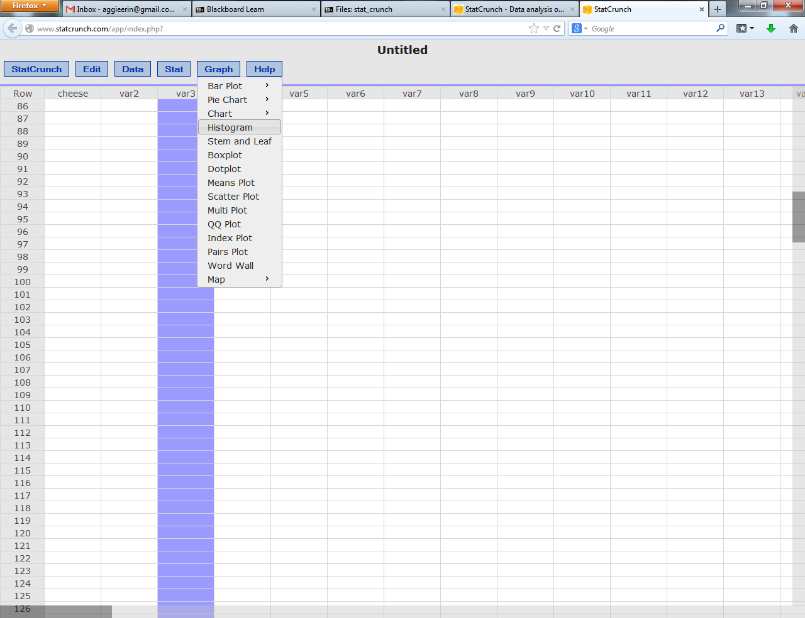

Click the column your data is in and then click compute.

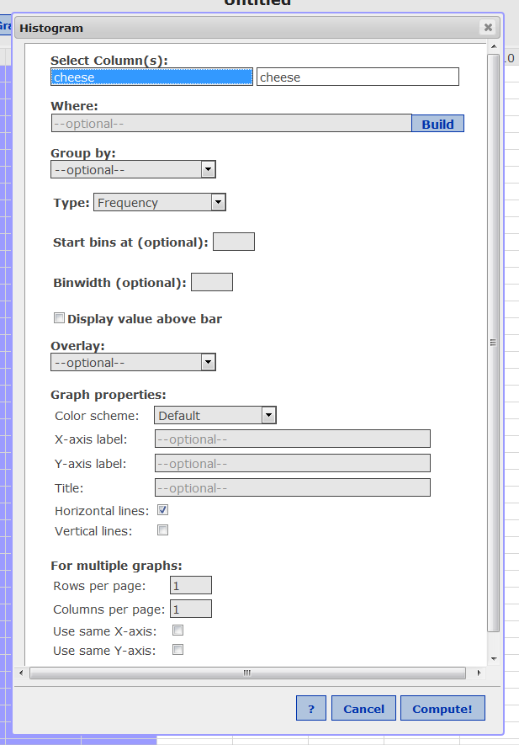

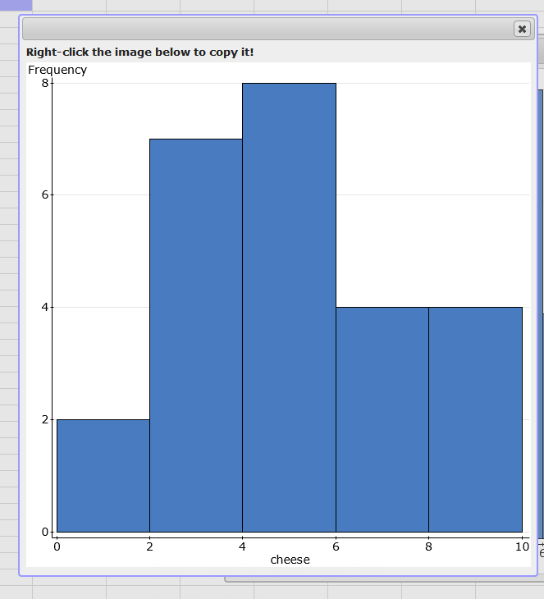

If you want to expand the chart (i.e. make the bottom have more options so that you can compare to StatLab), on the options screen put binwidth = 1.

